R. v. Carter, 2020 NWTTC 02

Date: February 18, 2020

File: T-1-CR-2018-002508

IN THE TERRITORIAL COURT OF THE NORTHWEST TERRITORIES

BETWEEN:

HER Majesty the Queen

- and -

JULIE-ANNE REBECCA CARTER

REASONS FOR SENTENCE
of the
HONOURABLE JUDGE DONOVAN MOLLOY

Heard at: Yellowknife, Northwest Territories

Date of Decision: December 13, 2019

Counsel for the Crown: Duane Praught

Counsel for the Accused: Jay Bran

[Section 5(1) of the Controlled Drugs and Substances Act]
[Sentencing]

R. v. Carter, 2020 NWTTC 02

Date: February 18, 2020

File: T-1-CR-2018-002508

IN THE TERRITORIAL COURT OF THE NORTHWEST TERRITORIES

BETWEEN:

HER Majesty the Queen

- and -

JULIE-ANNE REBECCA CARTER

REASONS FOR SENTENCE
of the
HONOURABLE JUDGE DONOVAN MOLLOY

- INTRODUCTION
    - Little fish are commonly enmeshed in the nets cast by law enforcement to stem the tide of illegal drugs into the Northwest Territories. While motives vary, these little fish often join the front-lines of the drug trade to feed their own addictions. When criminal organizations are ‘busted’ the little fish often receive scant public attention.
    - The justice system however does not forget the little fish. They are often surprised to learn that on sentencing, the starting point for trafficking in cocaine is between 3-4.5 years imprisonment. While personal circumstances must be factored in, it can be a shock for the first offenders, facing the prospect of significant time in prison despite having no previous criminal record.
    - Ms. Carter is a small fish caught in the net otherwise known as RCMP G Division: Project Gloomiest. As a 34 year old first offender and a single mother of a special needs child, Ms. Carter will start a 10 month sentence of imprisonment today for selling a police officer 2 ounces of baking soda. The reasons for imposing that sentence are detailed below.
- CIRCUMSTANCES OF THE OFFENCES
    - Attached as an appendix to this decision is the Agreed Statement of Facts tendered on September 13, 2019. As part of Project Gloomiest, the RCMP used undercover officers to make targeted purchasers of cocaine in Yellowknife. The goal was to identify the supply chain of illicit drugs into the Northwest Territories.
    - On March 10, 2018, after an undercover officer (UCO) asked a taxi driver about acquiring drugs, the UCO received a telephone call from Ms. Carter. That call resulted in the UCO accompanying Ms. Carter to the residence of an unknown male from whom the UCO purchased an ounce of cocaine for $2400. On analysis, the substance proved to be 27.7 grams of 94% pure cocaine.
    - On March 13, 2018, the UCO attended Ms. Carter’s apartment for the purpose of purchasing cocaine. Two unknown males arrived at Ms. Carter’s apartment shortly thereafter and sold the UCO 28.7 grams of cocaine for $2200 (later analyzed to be 91% pure). After the sale, the unknown males insisted that the UCO use some cocaine and accused the UCO of being a police officer on his refusal to do so.
    - The Agreed Statement of Facts is silent as to what, if any, benefit accrued to Ms. Carter in conjunction with these two sales of cocaine to the UCO.
    - On April 10, 2018 the UCO contacted Ms. Carter and inquired about purchasing 2 ounces of cocaine. Ms. Carter told the UCO that her supplier would not meet with him but that he could pay her and she would deliver the cocaine to him. Eventually the UCO paid $4500 to Ms. Carter for 2 ounces of cocaine. Ms. Carter left to procure the cocaine and returned, handing the UCO two plastic bags that each appeared to contain an ounce of powdered cocaine. Later analysis determined that these bags contained a total of 116.1 grams of sodium bicarbonate (baking soda).
    - Ms. Carter entered a guilty plea in regards to this transaction, for trafficking in a substance represented or held out to be cocaine, contrary to section 5(1) of the Controlled Drugs and Substances Act.
- THE OFFENDER’S CIRCUMSTANCES
    - Ms. Carter is a 34 year-old woman without any criminal record. The Pre-sentence Report details her childhood growing up in Ontario and her move to Yellowknife in 2011 to be closer to her family.
    - Substance abuse became a part of Ms. Carter’s life as a teenager and eventually led to her dropping out of school. While living in Ontario, she entered into a long-term abusive relationship. Her son was born during this time. Birth complications led to significant and lifelong challenges for her son. Despite those challenges he has fortunately exceeded early medical prognoses and appears to enjoy and participate in most of the activities of adolescents living in Yellowknife.
    - Ms. Carter has had gainful employment since moving to Yellowknife but a workplace injury and other issues led to her being unemployed at the time of these offences. Ms. Carter also became involved in other abusive relationships after moving to Yellowknife.
    - Ms. Carter candidly acknowledges her issues with substance addiction. She admits to continuing using drugs since her arrest for these offences. She maintains that she is pursuing treatment and says that she has shielded her son from the negative repercussions of her addictions. Unfortunately, as identified in the Pre-Sentence Report, her son has endured significant negative consequences due to his mother’s addictions and her commitment to and attendance for treatment/counselling has been far less than diligent.
    - I do not take these inconsistencies to be deliberate attempts to mislead the Court. Rather, they are rationalizations that perhaps serve to help Ms. Carter from being overwhelmed by the realization of what her addictions have cost her and her family. Lives held hostage by addictions are rife with the inherent contradictions occasioned by regular and prolonged usage of illicit drugs. Addicts become unrecognizable not only to family and friends, but also to themselves. Tragic circumstances often ensue when the choice to use drugs becomes a compulsion due to addiction.
- PARTIES’ POSITIONS
    - The Crown seeks a period of imprisonment of 18 months, a 12 month period of supervised probation, a DNA Order and a 10 year firearms prohibition. Ms. Carter’s counsel suggests that a period of 8-10 months imprisonment would be appropriate.
    - Trafficking offences involving cocaine (or substances held out to be cocaine) are not eligible for conditional sentences (house arrest) pursuant to section 742.1(e) of the Criminal Code.
- THE PURPOSE, PRINCIPLES AND OBJECTIVES OF SENTENCING
    - In determining a fit sentence for Ms. Carter, I am guided by the:
- Purpose, principles and objectives of sentencing set out in the Criminal Code;
- Circumstances of the offences and of Ms. Carter; and,
- Case law.
    - The fundamental purpose of sentencing is to contribute to respect for the law and the maintenance of a just, peaceful and safe society by imposing just sanctions that have one or more of the following objectives:
      - to denounce unlawful conduct;
      - to deter the offender and other persons from committing offences;
      - to separate offenders from society, where necessary;
      - to assist in rehabilitating offenders;
      - to provide reparation for harm done to victims or to the community; and
      - to promote a sense of responsibility in offenders, and acknowledgement of harm done to victims and to the community.
    - The principle of proportionality is a fundamental principle of sentencing. It requires that a sentence be proportionate to the gravity of the offence and the degree of responsibility of the offender.
    - The principle of parity states that a sentence should be similar to sentences imposed on similar offenders for similar offences committed in similar circumstances. As discussed below, there is an abundance of cases addressing sentencing for trafficking offences committed in the Northwest Territories.
- AGGRAVATING AND MITIGATING CIRCUMSTANCES
    - There are substantial mitigating circumstances. Ms. Carter has no criminal record. She entered a guilty plea without requiring a preliminary inquiry.
    - Ms. Carter readily acknowledges the criminality of her behaviour, recognizes the harms to the community associated with drug trafficking and appears to now recognize the connection between her own addictions and her involvement in the drug trade.
    - In terms of aggravating circumstances, I include Ms. Carter’s participation in and facilitation of the cocaine transactions on March 10 and 13, 2018. Courts of the Northwest Territories have long denounced trafficking in drugs, especially cocaine.
    - In R. v. Turner, 2006 NWTSC 64 the Court likened drug traffickers to predators on the community:
It has been said many times in this courtroom that the illegal cocaine trade is like a plague which has infested the social fabric of our community. Those who are involved in the supply and sale and trafficking of cocaine are like vultures or predators who are preying upon those weak members of the community who are addicted to this drug. The traffickers are doing this presumably for profit, or money. They, apparently, have no scruples about preying upon vulnerable people. For this reason alone, they ought to be punished. They are doing so even though there is a risk that they will end up in jail for a substantial period of time.
    - The harm associated with trafficking offences is substantial and ongoing. This point was recently reiterated by Charbonneau J. in R. v. Hussein, 2019 NWTSC 20:
6 The simple fact is that this is a very lucrative activity. It is one that causes immense harm in our communities. I have had occasion to say it in several sentencing decisions, and I will not go in as much detail here as I have in other cases but, to be blunt, this is a very expensive habit for the users to sustain. It leads to the commission of other crimes because people need to get their hands on money to sustain their habits. It means that people neglect their children and their family responsibilities. It has meant that businesses, well established businesses, have gone bankrupt and been destroyed because their owners have developed an addiction to crack and no longer cared about anything else. In extreme cases it has lead to deaths. Deaths by accident, deaths by homicide, and no end of pain and trauma for many people.
7 What this particular accused and the others who were sentenced for similar crimes did is a good example of what the Courts are trying to put an end to, admittedly with not very great success judging by the number of drug trafficking cases we continue to see. But the point is exactly that this is relatively easy money to make.
8 It is actually a very dangerous activity to get involved with, as some people have discovered the hard way, but on the surface it seems like an easy way to make money. And I suppose those who do get involved in this type of activity may even convince themselves that they are really not doing anything that is that bad because they are selling a product that people want to buy. The reality, as I have said, is quite different, and the harm that this causes is very real.
- TRAFFICKING AND HOLDING OUT
    - Ultimately, Ms. Carter’s sentence arises from trafficking in a substance held out as cocaine. She was paid $4500 for baking soda. That amount was paid to her because she represented the substance as cocaine. While she might not consider herself lucky in that in turned out she was dealing with a UCO, in the real world, such dealings can occasion retribution in the form of grievous bodily harm or death.
    - In part, due to the potential for such violence, sentences for trafficking in substances held out as illicit drugs tend to be on par with those for trafficking in actual drugs. Courts should not necessarily equate sentences however where what was trafficked was not a drug but a substance knowingly held out to be a drug, as stated by the Alberta Court of Appeal in R. v. Dumont, 1980 ABCA 123:
We are of the view that it is an error in principle to equate the offence of trafficking in a substance held out to be heroin with the offence of actually trafficking in heroin itself. We have here what amounts to an obtaining by false pretences. It is clear in this case that the appellant was aware that what he was selling was not heroin, as he had doctored up the substance which he was passing over himself from things purchased at a drug store.
We cannot treat the matter however merely as one of obtaining by false pretences. The Parliament of Canada has seen fit to make it a specific offence when one is trafficking in a substance held out, no doubt because it is all part and parcel of the drug scene. We think, too, that it is highly probable that in a case of holding out a substance to be heroin that the victim, if he is an addict, may crave the drug and turn to robbery or violence to get more money, and in addition there is the likelihood of violence to the one who has made the false pretence. We think the matter than has to be regarded more seriously than merely obtaining by false pretences.
    - Exclusively relying on sentencing precedents where actual drugs were trafficked also creates a risk of overstating an accused’s moral blameworthiness where a substance was known by the accused not be drugs: R. v. Churchill, 2019 ABCA 261.
- PARITY
    - The principle of parity requires that similar sentences be imposed on similar offenders for offences committed in similar circumstances. While Ms. Carter did not sell cocaine to the UCO, it is aggravating that she facilitated two prior purchases of actual cocaine by the UCO. Those transactions lent credence to her representations that what she was selling the UCO on April 10, 2018 was in fact 2 ounces of cocaine. It also appears that Ms. Carter took possession of the $4500 that she was paid by the UCO.
    - These aggravating circumstances distinguish Ms. Carter’s situation from those involving isolated transactions by those pretending to sell drugs. Her connections to the drug trade in Yellowknife and the UCO’s purchases of cocaine elevate her moral blameworthiness but does not mean it is equal to her cohorts.
    - Some recent sentencing decisions involving the offence of trafficking in cocaine are set out below:

Citation | Summary
R. v Stevens, 2019 NWTSC 32 | 26 year old, 12.5 grams cocaine, no priors, 2 years (joint submission)
R v. Paradis, 2019 NWTSC 27, 2019 Carswell NWT 44 | 5 years imprisonment, 130 grams, criminal record but no priors for drugs, number of firearms, sentence reduced as consequence of Charter breaches
R v. Hussein, 2019 NWTSC 20, 2019 Carswell NWT 43 | Accused sold about 2 ounces of crack cocaine per week as part of dial a dope operation, accused in 20s, no priors, guilty plea, 30 months (joint submission)
R v. Adzin, 2019 NWTSC 12, 2019 CarswellNWT 11 | 29 year old, 51 grams crack cocaine, serious priors but not for drugs, significant Gladue factors, 22 months (quasi-joint submission)
R. v. Mohamed, 2019 NWTSC 3, 2018 CarswellNWT 97 | Accused at large on related offences when found in possession of significant amount of cocaine and other drugs, related priors, convicted after trial, 30 months imprisonment
R. v. Randall, 2015 NWTSC 27 (N.W.T. S.C.) | First three drug transactions were small, fourth involved the sale of 28 pieces of crack cocaine weighing 17.3 grams, dial-a-dope operation, 18 years old, no criminal record, guilty plea, 20 months
R. v. Hodges, 2015 NWTSC 59 (N.W.T. S.C.) | Dial a dope operation, 26.9 grams crack cocaine, 26 years old, no priors, 30 months
R v. Tobac, 2018 NWTSC 20 (N.W.T. S.C.) | Guilty plea, one transaction of 0.4 grams of cocaine, addicted to cocaine, significant Gladue factors, prior criminal record, 6 months imprisonment
R. v. Cotchilly and Boyd, 2018 CarswellNWT 56 (N.W.T. S.C.) | Guilty plea of two accused to trafficking in cocaine, Cotchilly- one transaction for $20, Boyd- three transactions of small amounts of cocaine, Cotchilly- limited criminal record, Boyd- no priors, Cotchilly- 6 months imprisonment, Boyd- 8 months imprisonment
R v. Joe, 2018 CarswellNWT 6 (N.W.T. C.A.) | Guilty plea to one count of possession of cocaine for the purpose of trafficking and one count of possession of marijuana, half pound of marijuana and 8 grams of crack cocaine, over $5,000 in cash, 37 years old, no priors, 1 year imprisonment
R v. Forrest, 2018 NWTSC 77, 2018 CarswellNWT 82 | 35 years old, Indigenous, mother of 3, wholesale trafficking, hundreds of grams of cocaine, guilty plea, part of criminal organization, Gladue factors, 3 years imprisonment
R v. Lafferty, 2018 NWTSC 80, 2018 CarswellNWT 83  Lafferty continued | 58 year old, Indigenous, grandmother, dated criminal record, Gladue factors, significant amounts of various drugs including cocaine, 3 years imprisonment
R v. Bjornson, 2018 NWTSC 79, 2018 CarswellNWT 87 | Single mother of infant child, no prior record, sold undercover officer one gram of cocaine, guilty plea, six months' imprisonment followed by one year's probation (joint submission)
R. v. Simpson, 2018 NWTSC 61, 2018 CarswellNWT 58 | Guilty plea, joint submission, multiple but dated related prior convictions, 3 years imprisonment (joint submission)
R. v. King, 2018 NWTSC 44, 2018 CarswellNWT 72 | 111 grams of cocaine, Indigenous, 21 years old, no criminal record, unstable upbringing, 30 months' imprisonment and two years' probation
R. v. Dunn, 2018 NWTSC 29, 2018 CarswellNWT 68 | 48 year old, no priors, guilty plea, aided criminal organization in trafficking via job at airline, total of 19 ounces crack cocaine and 23 ounces powdered cocaine, 3 years imprisonment (joint submission)
R. v. Herback, 2018 NWTSC 17, 2018 CarswellNWT 13 | 36 year old, Indigenous, prior unrelated record, guilty plea, accused part of a dial a dope operation selling several ounces per day, wholesale trafficking, 3 years imprisonment
R v. Seyoume, 2018 NWTSC 14, 2018 CarswellNWT 9 | 21 years old, Kenyan refugee, part of lucrative dial a dope operation selling 2 ounces of crack cocaine per day, guilty plea, no priors, 30 months imprisonment
R. v. Dube, 2017 NWTSC 77, 2017 CarswellNWT 84 | 22 year old accused, prior record, head of significant trafficking network, cocaine (6-8 kilos per month), fentanyl, benzodiazepines, MDMA conspiracy to commit aggravated assault, 9 years imprisonment
    - In terms of parity, the circumstances of Ms. Carter’s offences and her personal circumstances appear closer to those in Tobac, Cotchilly and Boyd and Bjornson. While I regard the circumstances of her offence and aggravating circumstances as more serious than in those cases, I must remember that ultimately Ms. Carter is being sentenced for trafficking in baking soda, and not cocaine.
    - Ms. Carter is still a relatively young person, has a supportive family, is devoted to her son and has held gainful employment in the past. She can, with considerable effort and treatment, overcome her addictions and move on to a healthier, more productive chapter of her life. While she has to be imprisoned, I view a sentence of 10 months imprisonment as appropriate in all of the circumstances of this case.
- SENTENCE
    - Ms. Carter is sentenced to serve a period of imprisonment of 10 months.
    - Ms. Carter, pursuant to section 109 of the Criminal Code, is prohibited from possessing any firearm, cross-bow and explosive substance for a period of 10 years and prohibited for life from possessing any prohibited firearm, restricted firearm, prohibited weapon, prohibited device and prohibited ammunition.
    - Pursuant to section 487.051(3) of the Criminal Code, I authorize the taking of the number of samples of bodily substances from Ms. Carter that is reasonably required for the purpose of forensic DNA analysis.
    - Finally, following the expiration of her term of imprisonment, Ms. Carter will be subject to an 18 month period of probation, on the following terms:

(a) Keep the peace and be of good behaviour;

(b) Appear before the court when required to do so by the court;

(c) Report to an adult probation officer:
(i) within five working days of your release from prison; and,
(ii) report thereafter when required by the adult probation officer and in the manner directed by the adult probation officer;
(d) Remain within the Northwest Territories unless written permission to go outside that jurisdiction is obtained from the court or the adult probation officer;

(e) Abstain from consuming illegal drugs, except for medications prescribed by a licensed medical practitioner;

(f) Complete a minimum of 100 hours of community service work, at a rate of no less than 6 hours per month;

(g) Attend and participate in counselling, programming or other related activities as recommended by the adult probation officer;

(h) Provide, for the purpose of analysis, a sample of a bodily substance prescribed by regulation on the demand of a peace officer or a probation officer, at the place and time and on the day specified by the person making the demand, if that person has reasonable grounds to believe that you have breached the condition of this order that requires you to abstain from the consumption of illegal drugs; and

(i) Provide, for the purpose of analysis, a sample of a bodily substance prescribed by regulation at regular intervals that are specified by a probation officer in a notice in Form 51 served on you.

Donovan Molloy
T.C.J.
Dated at Yellowknife, Northwest Territories, this 18th day of February, 2020.

Appendix A
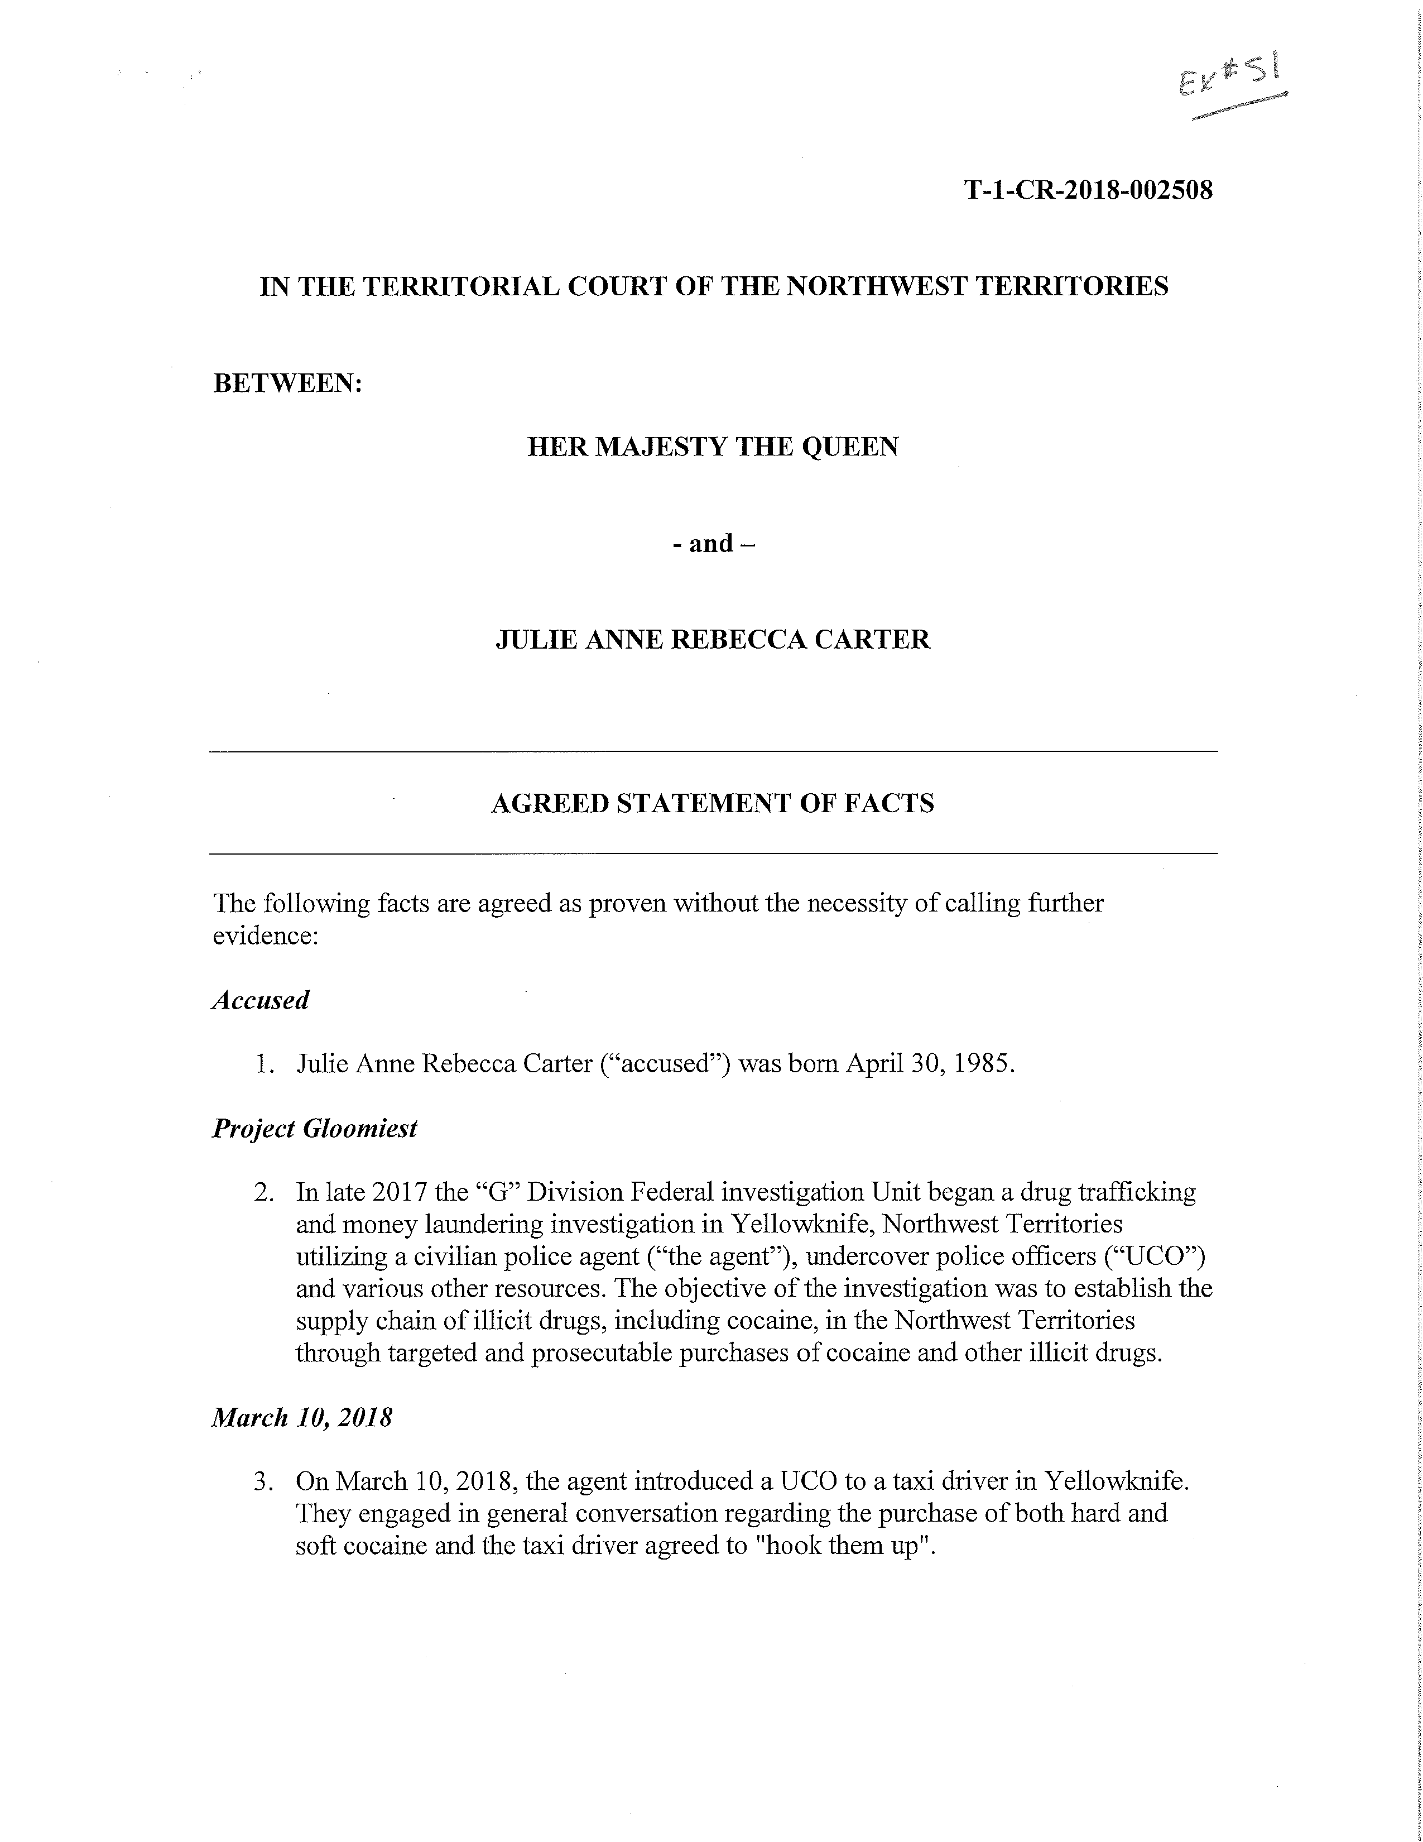

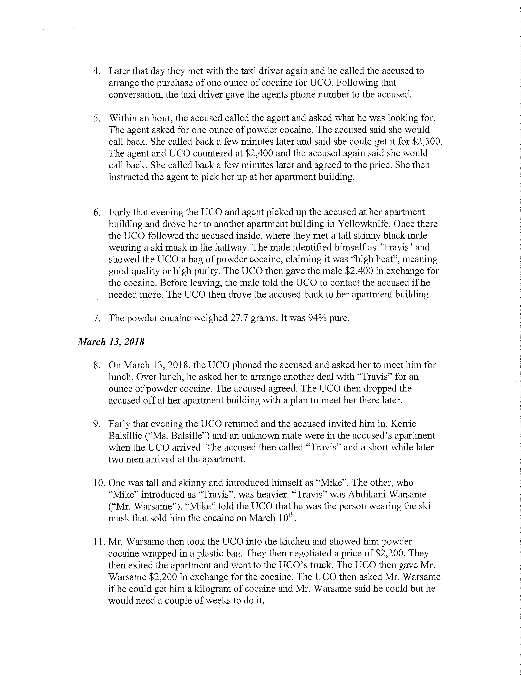

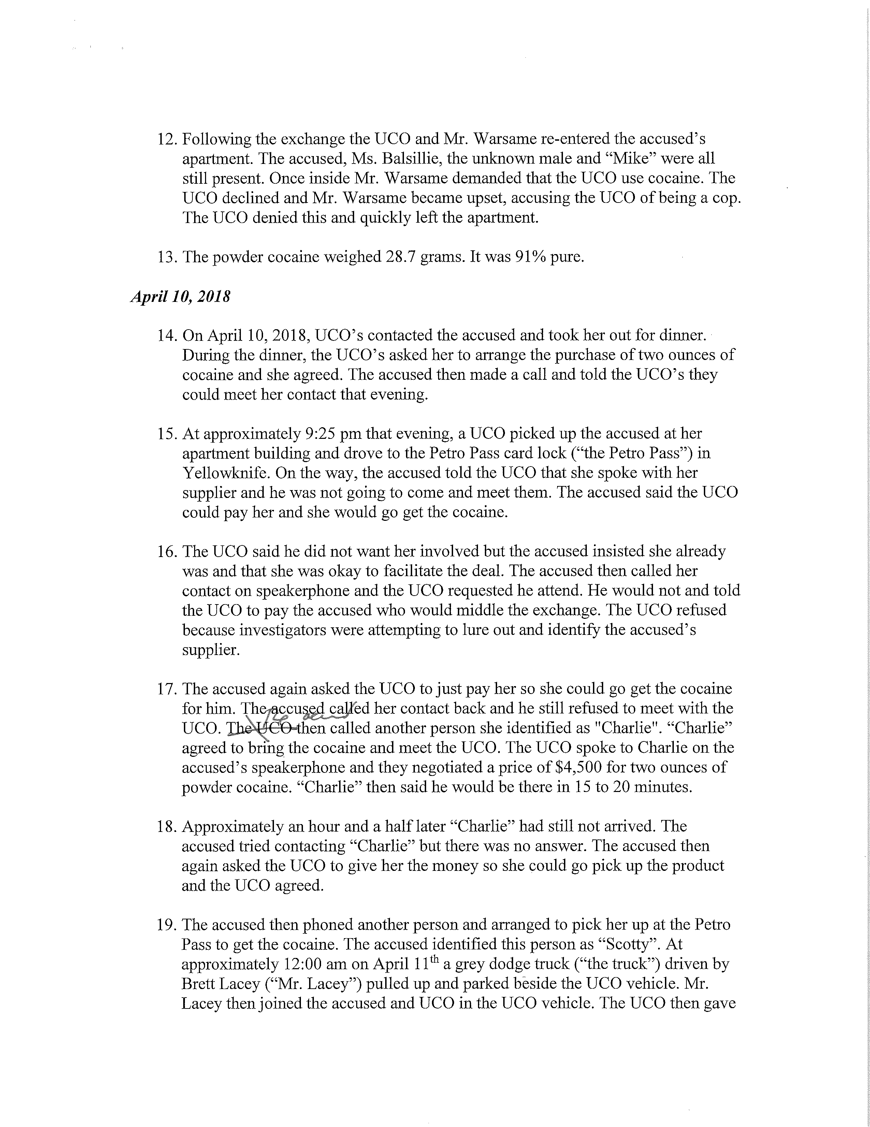

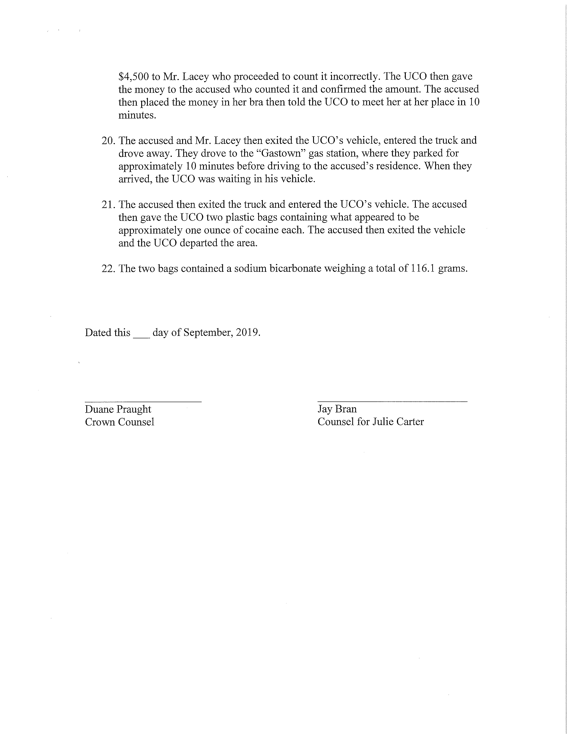

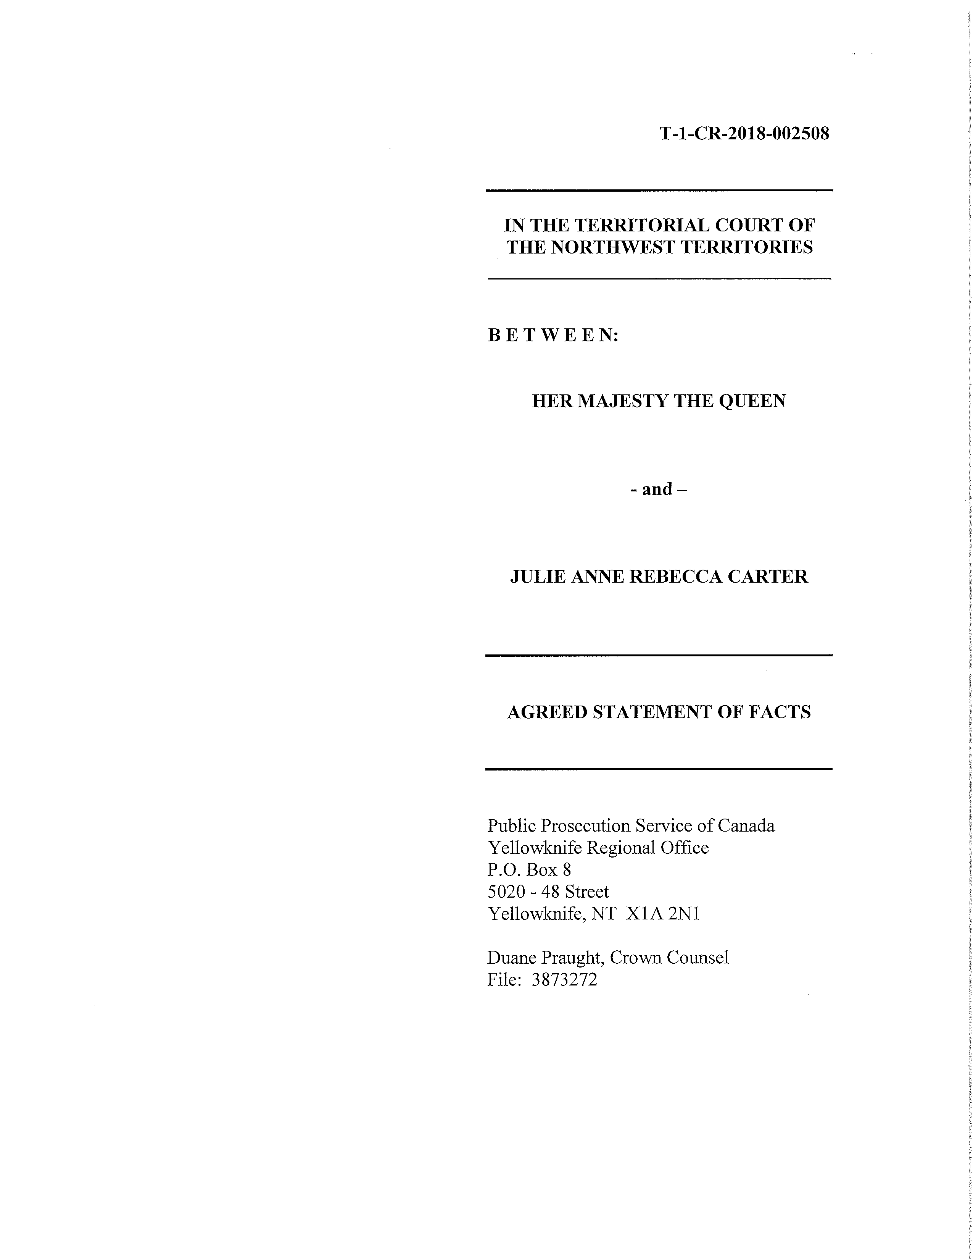

R. v. Carter, 2020 NWTTC 02

Date: February 18, 2020

File: T-1-CR-2018-002508

______________________________________

IN THE TERRITORIAL COURT OF THE NORTHWEST TERRITORIES

______________________________________

BETWEEN:

HER MAJESTY THE QUEEN

- and -

JULIE-ANNE REBECCA CARTER

______________________________________

REASONS FOR DECISION

of the

HONOURABLE JUDGEDONOVAN MOLLOY

______________________________________

[Section 5(1) of the Controlled Drugs and Substances Act]

