R. v. Beaverho, 2019 NWTTC 11

Date: 2019 08 09

File: T-2-CR-2019-000091

IN THE TERRITORIAL COURT OF THE NORTHWEST TERRITORIES

BETWEEN:

HER Majesty the Queen

- and -

JOSEPH CHARLES BEAVERHO

REASONS FOR SENTENCE
of the
HONOURABLE JUDGE DONOVAN MOLLOY

Heard at: Yellowknife, Northwest Territories

Date of Decision: August 9, 2019

Counsel for the Crown: Trevor Johnson

Counsel for the Accused: Jay Bran

[Section 122 of the Criminal Code]
[Sentencing]

R. v. Beaverho, 2019 NWTTC 11

Date: 2019 08 09

File: T-1-CR-2019-000091

IN THE TERRITORIAL COURT OF THE NORTHWEST TERRITORIES

BETWEEN:

HER Majesty the Queen

- and -

JOSEPH CHARLES BEAVERHO

REASONS FOR SENTENCE
of the
HONOURABLE JUDGE DONOVAN MOLLOY

- INTRODUCTION
    - Providing employees access to hundreds of thousands of dollars of public funds requires trust. Circumstances without financial controls in place make employers solely dependent on trust. Solely relying on trust is a main ingredient of the recipe for fraud. In this case, tempted by addiction and influenced by other factors, Mr. Beaverho started down the slippery trail of misappropriating public funds. The frauds continued for two years before their detection. As a result of his breach of trust; $120,721.24 was stolen from a fund intended to assist Indigenous students in their pursuit of post-secondary education.
    - Ultimately I must decide what is a fit sentence based on the circumstances of the offence and Mr. Beaverho’s circumstances. In arriving at that decision, relevant considerations include:
- What is the proper place of his Gladue factors in determining sentence?
- What consideration should be given to the fact that Mr. Beaverho occupied a public office at the time of committing this fraud?
- Should Mr. Beaverho be allowed to serve a period of imprisonment in the community pursuant to section 742.1?
    - Mr. Beaverho entered an early guilty plea to an offence pursuant to section 122 of the Criminal Code (as the section read at the time of his offence). He also admitted responsibility to his employer in 2013 when the fraud was discovered and confirmed by auditors employed by the Independent Audit Bureau (IAB). The IAB provided the results of its audit and his confession to the Royal Canadian Mounted Police in May of 2013. For unknown reasons, he was not charged until January 3, 2019.
- CIRCUMSTANCES OF THE OFFENCES
    - Attached as an appendix to this decision is the Agreed Statement of Facts tendered on August 7, 2019. It details the fraud, carried out between April 15, 2010 and February 12, 2012, during Mr. Beaverho’s employment as a Program Officer with the Tłįchǫ Scholarship Program (TSP).
    - Mr. Beaverho’s duties included disbursing money to offset the expenses of Indigenous students pursuing post-secondary education. Sometimes payments went directly to the students by way of reimbursement for expenses. Payments were also made directly to post-secondary institutions by way of tuition and other invoices.
    - In October of 2010, a student’s tax return was re-assessed by the Canadian Revenue Agency as she had not reported funds she received from the TSP. As the student never received the funds in question, she contacted the Tłįchǫ Community Services Agency (TCSA). In looking into her inquiry, TSCA employees discovered financial irregularities that led to the audit by the IAB and ultimately, in Mr. Beaverho’s conviction.
    - Mr. Beaverho fraudulently deposited 69 cheques from the TSP into his own accounts. He maintains that the monies he misappropriated were mostly spent in pursuit of a gambling addiction.
    - As Behchokǫ̀ is a tight-knit community of approximately 1800-1900 residents, Mr. Beaverho’s employment prospects disappeared on discovery of the fraud. As such, he was unable to secure gainful employment and has not repaid any amount. As his 65th birthday is imminent, there is no real prospect of Mr. Beaverho repaying the money. While he desires to work, this conviction will not improve his prospects as they pertain to securing employment. He has offered to work on a volunteer basis for the Tłįchǫ Government however the circumstances of his departure from their employment may make that untenable.
- THE OFFENDER’S CIRCUMSTANCES
    - Mr. Beaverho is a 64 year-old Indigenous male without any criminal record. The Pre-sentence Report details that he was raised in a traditional lifestyle and all was well until he was abducted by government officials at age 7 and placed in a residential school. At that school he and other Indigenous children were abused by ‘foreign’ speaking authority figures for speaking their own language. Mr. Beaverho experienced other abuses as well that left him with psychological and emotional scars that continue to present day.
    - Despite the abuse he endured in his childhood he maintained gainful employment throughout his life, was a productive member of his community and earned the respect of many. I note his reputation is not entirely shredded as is evidenced in the letters of support tendered by his counsel.
- PARTIES’ POSITIONS
    - The Court received a joint submission recommending a period of imprisonment of 2 years less one day. That submission includes allowing him to serve that sentence in the community pursuant to a conditional sentence order. The conditions of that order as recommended by the parties would be very restrictive and continue for the duration of the conditional sentence order.
- THE PURPOSE, PRINCIPLES AND OBJECTIVES OF SENTENCING
    - In determining a fit sentence for Mr. Beaverho, I am guided by the:
- Purpose, principles and objectives of sentencing set out in the Criminal Code;
- Circumstances of the offences and of Mr. Beaverho, including his Indigenous status and associated Gladue factors; and,
- Case law.
    - The fundamental purpose of sentencing is to contribute to respect for the law and the maintenance of a just, peaceful and safe society by imposing just sanctions that have one or more of the following objectives:
      - to denounce unlawful conduct;
      - to deter the offender and other persons from committing offences;
      - to separate offenders from society, where necessary;
      - to assist in rehabilitating offenders;
      - to provide reparation for harm done to victims or to the community; and
      - to promote a sense of responsibility in offenders, and acknowledgement of harm done to victims and to the community.
    - The principle of proportionality is a fundamental principle of sentencing. It requires that a sentence be proportionate to the gravity of the offence and the degree of responsibility of the offender.
    - The principle of parity states that a sentence should be similar to sentences imposed on similar offenders for similar offences committed in similar circumstances.
    - Finally, all available sanctions other than imprisonment that are reasonable in the circumstances should be considered for all offenders, with particular attention paid to the circumstances of Indigenous offenders.
- VICTIM IMPACT
    - A victim impact statement was filed by the student that contacted the TCSA in October of 2010. The impact of this offence on her is substantial and enduring. Mr. Beaverho’s theft of her identity to commit fraud resulted in her abandoning part of her post-secondary education goals. Her sense of betrayal is aggravated by the fact that it was perpetrated by a person employed by an agency with a mandate to aid Indigenous students in pursuing their educations.
- AGGRAVATING AND MITIGATING CIRCUMSTANCES
    - There are substantial mitigating circumstances. Mr. Beaverho has no criminal record. He entered guilty pleas to the charge at his earliest opportunity. In fact, he confessed his involvement to the IAB auditors in 2013. Despite his confession, a trial in regards to this matter would have consumed significant police, court and other resources. Perhaps the only other thing that he could have done is repay some or all of the funds, however I accept that he lacked the means of doing so.
    - In terms of aggravating circumstances, they are primarily the breach of trust, his status as a public officer and the significant amount of money defrauded from the program.
    - As a member of the Indigenous community, his betrayal may be felt more keenly in that the funds he stole were intended to aid Indigenous students in pursing post-secondary education. It was also not an isolated incident and involved 69 separate frauds over the course of 2 years. While not in any way an excuse, his ability to engage in the frauds over that period of time is partly due to their being no controls or procedures in place to deter or detect such activities. The ‘protocol’ that was in place is described in the Agreed Statement of Facts, “There was no written policy or procedure manual for the Program Officer role. Mr Beaverho would operate under verbal directions given during meetings he attended with TCSA and Tłįchǫ Government officials.”
- GLADUE FACTORS
    - I must consider section 718.2(e) and the guidance offered by the Supreme Court of Canada in applying Parliament’s directive aimed at addressing the circumstances of Indigenous offenders (R. v. Gladue, [1999] 1 SCR 688; R. v. Ipeelee, [2012] 1 SCR 433). Mr. Beaverho is impacted by many Gladue factors that are considered as lessening moral blameworthiness.
    - As with many pre-sentence reports in this jurisdiction, it contains details of trauma and abuses suffered. I see no need to enumerate them beyond noting that I find them to be significant and substantial. That finding lends support to accepting the joint submission that Mr. Beaverho be permitted to serve the custodial sentence in the community as an alternative to actual imprisonment.
- PUBLIC OFFICER
    - Frauds by employees involve a breach of trust. Employers must be able to rely on that trust as even vigorous financial controls can be circumvented by employees determined to misappropriate funds.
    - Mr. Beaverho was not just an employee, he held a public office and thus he also violated the trust of the public, and in particular, the Indigenous students intended to benefit from the monies he stole. Does the fact that he occupied a public office mean that a conditional sentence would be inconsistent with the fundamental purpose and principles of sentencing?
    - In short, the answer is no. There are a number of decisions which confirm that a conditional sentence is available and appropriate for public officers that commit fraud. Those decisions include: R. v. MacEachern, 1999 CanLII 7062 and R. v. Davies, 2005 CanLII 63757.
    - There are appellate decisions holding that the emphasis on deterrence, where public officers commit fraud, militates against allowing a sentence of imprisonment to be served in the community. One such decision is R. v. Moccasin, 2006 SKCA 5, in which the Saskatchewan Court of Appeal overturned a conditional sentence imposed on a 60 year old Indigenous first offender who, along with another person, defrauded a band council of over $1,000,000. That amount far exceeds the amount stolen here. Further, in order to give meaning to the exercise restraint in sentencing Indigenous offenders, and considering the significant Gladue factors that contributed to Mr. Beaverho’s offending, allowing him to serve his sentence in the community must be an available alternative to actual imprisonment.
- PARITY
    - The principle of parity requires that similar sentences be imposed on similar offenders for offences committed in similar circumstances. There are a number of examples from this jurisdiction where Indigenous first offenders received conditional sentences of imprisonment in relation to substantial frauds that severely impacted their communities. One such example is R. v. Kanayok, 2014 NWTSC 75. Ms. Kanayok misappropriated $60,399.04 from the Olokhaktomiut Hunters and Trappers Committee and received a conditional sentence of 2 years less a day. The Kanayok decision also cites 3 other similar cases where conditional sentences were imposed.
- SENTENCE
    - Mr. Beaverho is sentenced to serve a period of imprisonment of 2 years less one day. I am satisfied that his service of the sentence in the community would not endanger the safety of the community and would be consistent with the fundamental purpose and principles of sentencing. As such, for the duration of that sentence, he will be bound by the following conditions pursuant to section 742.3:

(a) Keep the peace and be of good behaviour;

(b) Appear before the court when required to do so by the court;

(c) Report to a supervisor:
  - within two working days; and,
  - thereafter, report when required by the supervisor and in the manner directed by the supervisor;
(d) Remain within the Northwest Territories unless written permission to go outside that jurisdiction is obtained from the court or the supervisor;

(e) Abstain from consuming alcohol or drugs, except for medications prescribed by a licensed medical practitioner;
(f) Complete a minimum of 180 hours of community service work, at a rate of no less than 8 hours per month;

(g) Provide, for the purpose of analysis, a sample of a bodily substance prescribed by regulation on the demand of a peace officer, the supervisor or someone designated under subsection 742.3(7) to make a demand, at the place and time and on the day specified by the person making the demand, if that person has reasonable grounds to suspect that the offender has breached a condition of the order that requires them to abstain from the consumption of drugs, alcohol or any other intoxicating substance;

(h) Attend and participate in counselling, programming or other related activities as recommended by your conditional sentence supervisor;

(h.1) Reside at House No. 615, Behchokǫ̀, Northwest Territories and remain at that address unless prior approval to change residence is obtained from the supervisor or the court;

(i) Remain within your residence (or the property immediately adjacent to your residence) at all times, except, you may be absent:

- In the event of a medical emergency involving yourself or a member of your immediate family;
- To attend church services once per week;
- To complete community service work as approved in advance by your supervisor;
- On Tuesdays and Thursdays of each week you may be absent from 1pm to 3pm to attend to personal matters and errands;
- On Saturday of each week, you may be absent from 1pm to 5pm to attend to personal matters and errands in Yellowknife;
- If you have prior approval of your supervisor, for the amount of time approved;
(j) You shall personally attend at the door of your residence and present yourself to the police within 5 minutes of their attendance during periods that you are not permitted to be absent;
(k) You shall refrain from any contact or communication with Marissa Schutz and refrain from attending at her place of residence, employment or education.

Donovan Molloy
T.C.J.

Dated at Yellowknife, Northwest Territories,
this 9th day of August, 2019.

APPENDIX

IN THE TERRITORIAL COURT OF THE NORTHWEST TERRITORIES

BETWEEN:
HER MAJESTY THE QUEEN

- and -

JOSEPH CHARLES BEAVERHO

AGREED STATEMENT OF FACTS

The following facts are admitted by the accused without the necessity of calling evidence,
pursuant to s. 655 of the Criminal Code:

- Joseph Beaverho between April 15, 2010 and February 12, 2012 committed a breach of
trust in connection to the duties of his office by fraudulently converting for his own use scholarship cheques in the amount of $120,721.24 from the Tłįchǫ Community Services Agency (“TCSA”).

Tłįchǫ Scholarship Program

- During the period of 2005 to 2012 the Tłįchǫ Government provided contribution
agreement funding of up to $800,000 a year to the TCSA to deliver the post-secondary
Tłįchǫ Scholarship Program (“TSP”). Tłįchǫ citizens attending post-secondary
educational institutes in Canada were eligible for TSP funding.

- The TSP provided for direct payment to institutions on behalf of students, payment to students for forthcoming eligible post-secondary expenses, and reimbursements to
students who had already paid eligible post-secondary expenses. Reimbursements were
made upon the provision of receipts or other confirmation of payment.

- The TSP Program Officer was authorized to review and approve the Scholarship Program applicants' eligibility for funding. The Program Officer role included requesting cheques be drafted as scholarship payments payable to students, or payable the school they attended, or as reimbursement payments for eligible expenses.

- Mr Beaverho was the TSP Program Officer from August 22, 2005 until April 29, 2012.

- There was no written policy or procedure manual for the Program Officer role. Mr Beaverho would operate under verbal directions given during meetings he attended with TCSA and Tłįchǫ Government officials.

- Mr Beaverho authorized and prepared cheque requisitions and delivered the cheques to
the Scholarship Program funding recipients by hand, by deposit into bank accounts, or by mail.

Initial Reporting of Misappropriated Funds

- On October 31, 2010, Marissa Schutz, a former TSP recipient, contacted TCSA by email regarding her 2011 Income Tax Re-assessment by the Canada Revenue Agency for
$1,944.00 of unreported income based on TSP payments in her name. Ms Schutz did not receive those payments nor a Form T4A from TCSA reporting the income.

- As a result of the complaint by Ms Schutz, TCSA employees reviewed the files of the
TSP and detected irregularities in payments made in Schutz’s name by the TSP.

Tłįchǫ Scholarship Program Audit

- On November 27, 2012, Kevin Armstrong, the then-acting Chief Executive Officer of TCSA reported the financial irregularities to the Government of Northwest Territories (GNWT) Comptroller General. The Comptroller General directed the Internal Audit Bureau (IAB) to investigate.

- The IAB audited the TSP with the objective to determine the extent of loss to the GNWT and TCSA and included in the scope of its audit:
  - The financial records of TCSA from April 1, 2010 until April 30, 2012;
  - Confirmation information from the TSP student payees;
  - A forensic analysis of Mr Beaverho’s work computer and its files;
  - Mr Beaverho’s financial records that he voluntarily turned over to the IAB; and,
  - Four interviews between IAB auditors and Mr Beaverho.

- The IAB examined over 850 TSP cheques paid during the audit period. Approximately 650 of the cheques were mailed or handed directly to the payees. The rest, 211 cheques totalling $317,259, were deposited at the Behchoko Northern Store. Of the 211 cheques:

  - Five cheques totalling $3,861 were deposited to students’ personal accounts;

  - 26 cheques totalling $32,225 were deposited at the Northern Store but account numbers or other identifying information was illegible or missing; and,

  - 180 cheques totalling $281,173 were deposited at Behchoko Northern Store to Mr Beaverho’s card accounts without the payee's endorsement.

- Mr Beaverho stated to the IAB that his card account at the Northern Store was set up to facilitate the transfer of scholarship payments to students who did not have bank
accounts.

- The audit of the 180 cheques deposited in Mr Beaverho’s account revealed 125 cheques totalling $186,000 that were represented as being regular scholarships payments (“the Scholarship Cheques”) and 55 cheques totalling $95,073 that were represented as being reimbursement payments (“the Reimbursement Cheques”).

- Of the Scholarship Cheques 23 cheques totalling $39,000 were fraudulently deposited in Mr Beaverho’s account for his own use, described below. Of the Reimbursement
Cheques 46 cheques totalling $81,621.24 were fraudulently deposited in Mr Beaverho’s account for his own use, described below. The 69 fraudulently deposited cheques sum to an amount of $120,621.24.

The Scholarship Cheques

- Although the IAB traced the deposit of the 125 scholarship cheques totalling
$186,000 to Mr Beaverho’s card account, the IAB could not match corresponding withdrawals from that account for the benefit of the payees. The IAB attempted to contact each scholarship payee by mail to ask if they had received the payments that were issued in their names. The results were:

  - 11 cheques totalling $15,300 were received by the payees;
  - 23 cheques totalling $39,100 were confirmed as being not received by the intended payee students. The IAB analysis of those payments revealed that:
    - There were no scholarship applications to support 21 of those cheques indicating that the requests for payment were fictitious;
    - There were applications on file for two payees, however the payess had not gone to school, making the individuals ineligible for scholarship assistance at the time the payments were issued;
    - All 23 requests for payment were made by Mr Beaverho;
    - All 23 issued cheques were received by Mr Beaverho;
    - All 23 issued cheques were deposited to Mr Beaverho’s card
accounts at the Behchoko Northern Store;
- No responses were received from the payees for the remaining 91 regular scholarship cheques totalling $131,700. The IAB analysis of those payments revealed that:
  - All 91 requests for payment were made by Mr Beaverho;
  - All 91 issued cheques were received by Mr Beaverho;
  - All 91 issued cheques were deposited to Mr Beaverho’s card
accounts at the Behchoko Northern Store;
  - There were scholarship applications supporting 14 of the cheques totalling $19,000; and,
  - There were no scholarship applications supporting 77 of those cheques totalling $112,700.

The Reimbursement Cheques

- The Reimbursement Cheques were all based on fictitious supporting documents.

- Of the Reimbursement Cheques, 46 cheques totalling $81,621.24 had a complete audit trail from the originating documents to the deposit, linking Mr Beaverho to each
step. The requests for these 46 reimbursements showed that:

  - ATM receipts for purchases or withdrawals used to support the purported student reimbursements were those made with Mr Beaverho’s own debit or credit cards at various locations in Yellowknife and Edmonton, AB, and not were not eligible payments by a student;
  - Mr Beaverho had opportunity to make the purchases or withdrawals in Yellowknife or Edmonton because he was on work travel, vacation leave or the dates were on weekends;
  - Documents provided to be receipts or confirmations of payments from various post-secondary institutions were fraudulent and were not issued by those institutions, as confirmed by the institutions;
  - Requests for payments or cheque requisitions were prepared by or signed by Mr Beaverho;
  - The reimbursement cheques were deposited at the Northern Store in Behchoko to Mr Beaverho’s accounts; and
  - The funds were not forwarded to the cheque payees.

- Nine cheques totalling $13,451.84 showed a similar pattern of fraudulent support documentation as noted above in the other 46 but the IAB was unable to complete an audit trail.

Computer Analysis

- A forensic analysis of Mr Beaverho’s work computer discovered one computer file created on September 27, 2010, of a fraudulently created invoice purporting to be from a university. This document was used by Mr Beaverho to request a reimbursement
payment on September 28, 2010, to a payee in the amount of $1,944 for which a cheque was issued on September 30, 2010. This cheque was then deposited to Joseph’s
Behchoko Northern Store card account.

IAB Interviews with Mr Beaverho

- The IAB interviewed Mr Beaverho on four occasions. Of relevance:

  - On January 24, 2013, Mr Beaverho admitted that he took money from the TSP to pay gambling debts. Joseph estimated that he had cashed between thirty to
forty cheques for that purpose and Joseph signed a consent form allowing the
IAB to access his personal banking and financial records; and

  - On March 19, 2013, Mr Beaverho admitted that if students did not receive
payments it was probably because he had used the money to pay for his
gambling. Mr Beaverho admitted to not keeping track of how much of the TSP
funds he used for gambling and further admitted that the loss to GNWT and
TCSA was at least $100,000.

- On February 5, 2013, Mr Beaverho wrote a letter to Kevin Armstrong. A copy of that letter is attached as Appendix A to this Agreed Statement of Facts.

- In May, 2013, the GNWT forwarded a package containing the IAB’s independent audit to the RCMP.

Dated this 7th day of August, 2019

________________________________________________ _______________________________________________

Trevor Johnson
Counsel for the Director of
Public Prosecutions
Jay Bran
Counsel for
Joseph Charles Beaverho

_____________________________________________________

Joseph Charles Beaverho

Appendix A

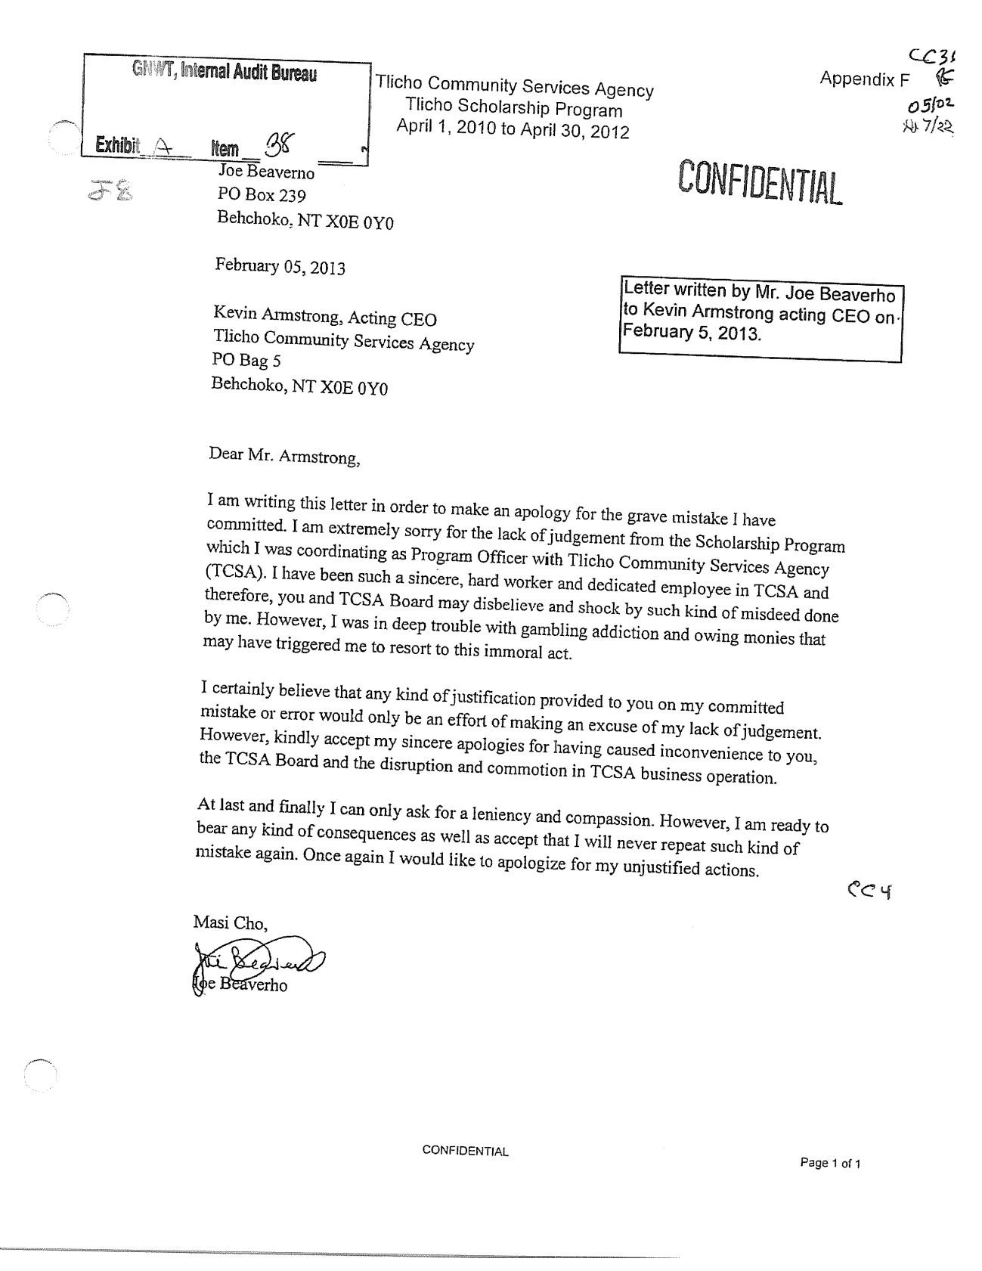

R. v. Beaverho, 2019 NWTTC 11

Date: 2019 08 09
File: T-2-CR-2019-000091

IN THE TERRITORIAL COURT OF THE NORTHWEST TERRITORIES

BETWEEN:

HER MAJESTY THE QUEEN

- and -

JOSEPH CHARLES BEAVERHO

REASONS FOR DECISION
of the
HONOURABLE JUDGE DONOVAN MOLLOY

[Section 122 of the Criminal Code]

